Week 4: Order Management System

An e-commerce company requires a database system to manage customer orders. Customers can purchase multiple products through a unified platform checkout. The system maintains order dates, individual purchased items, and quantities. Product unit prices and total bill amounts are tracked for accounting. Relational constraints link customers to orders and items via order details.
- Design Orders and Order_Details Tables:

Order entity

  - Order_ID: Unique order identifier
  - Customer_ID: Customer reference
  - Order_Date: Date of order placement
  - Total_Amount: Total bill amount
  - Order_Status: Pending, Shipped, or Delivered.
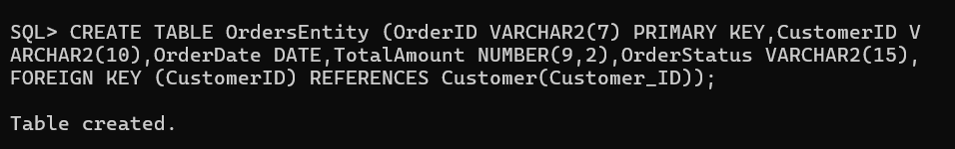
Order_Details Entity

- Order_Detail_ID: Unique detail identifier
- Order_ID: Order reference
- Product_ID: Product reference
- Quantity: Number of products purchased
- Price: Product price
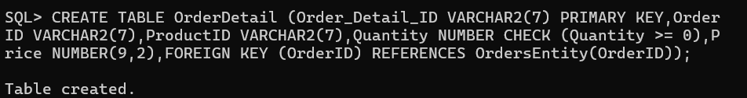

2. Establish Relationships
Customer and Orders:

- One customer can place multiple orders.
- Each order belongs to one customer.
Orders and Products
- One order can contain multiple products.
- One product can appear in multiple orders.
This relationship is implemented using the Order_Details Table.

Apply Constraints
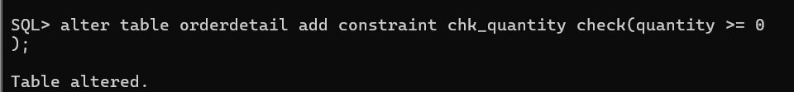
Manage Customer Product Orders (Orders Table)
To manage customer product orders using the Orders table, you execute SQL commands and transactions that handle order creation, item addition, calculation, status updates, and viewing details:
- Create a new order for a customer: Insert a master record into the Orders table containing the unique OrderID, reference to CustomerID, OrderDate, initial TotalAmount, and starting OrderStatus (e.g., 'Pending').
- Add multiple products to an order: Insert individual line items into the OrderDetail table linking back to the OrderID, providing the ProductID, Quantity, and Price.
- Calculate total order amount: Aggregate or sum the calculated line item subtotals (Quantity $×$ Price) across the order details to update or verify the TotalAmount column in the Orders table.
- Update order status: Modify the lifecycle stage of the order in the Orders table using an UPDATE statement (e.g., changing status from 'Pending' to 'Shipped' or 'Delivered').
- View complete order details: Use SELECT queries with JOIN operations between the Customer, Orders, and OrderDetail tables to retrieve comprehensive data on who placed the order, what items were bought, and their totals.
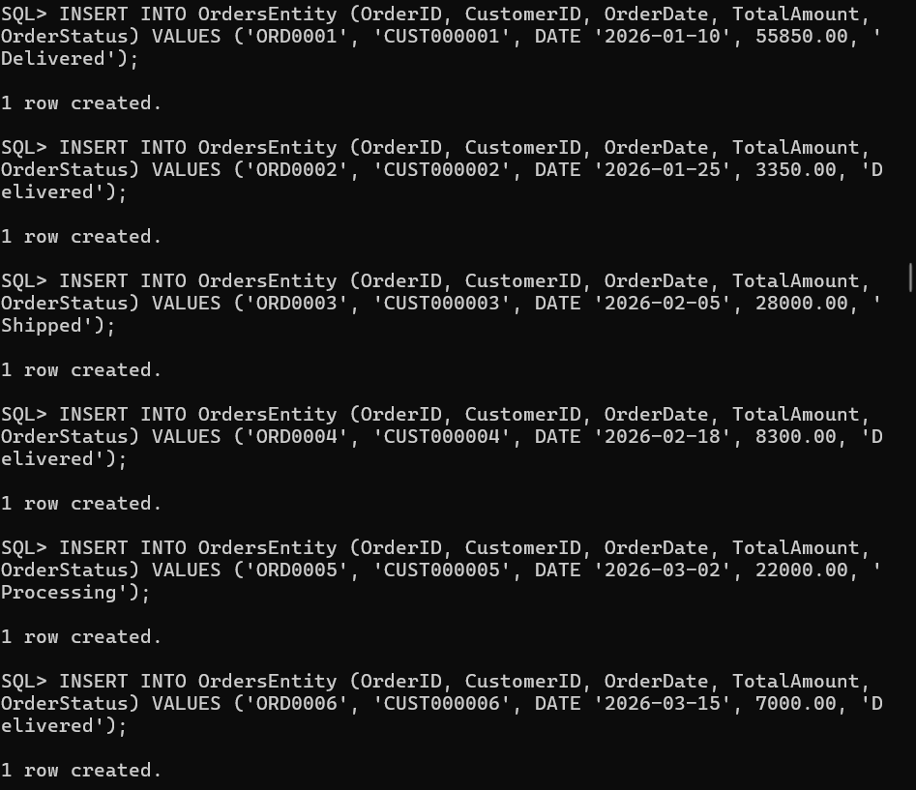
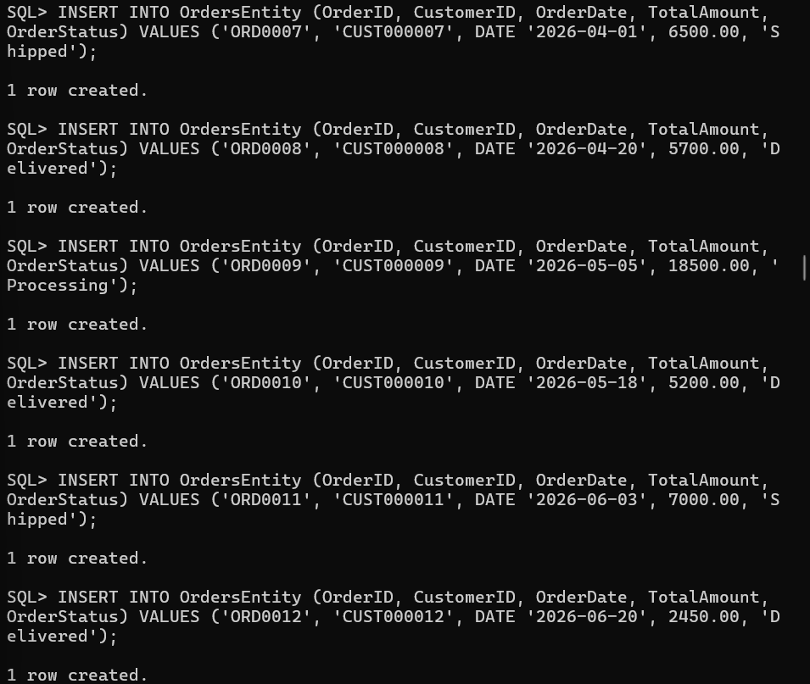
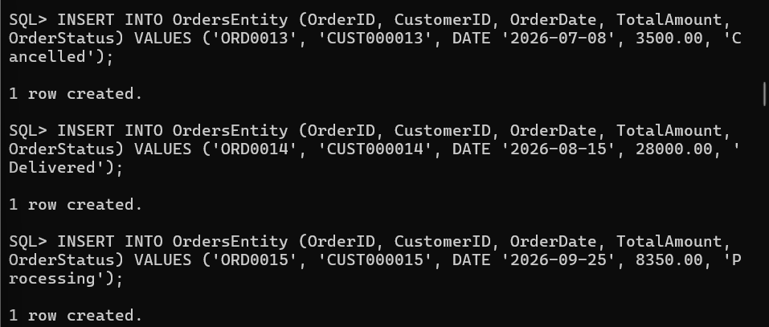
Select query:
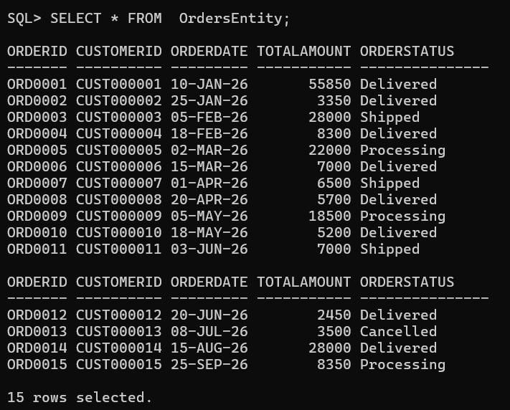
Create orderdetails:
To manage individual items inside an order using the Order_Details table, you execute SQL commands and tasks that handle line-item insertion, price calculations, and record modifications:Add multiple products to an order: Insert individual line items into the OrderDetail table by specifying the unique Order_Detail_ID, the parent OrderID, the ProductID of the item being purchased, the Quantity, and the unit Price.Calculate line-item subtotals: Determine the cost for each ordered product row by multiplying its quantity by its price , which feeds into the order's overall bill amount.Update product quantity: Modify existing line-item quantities in the OrderDetail table using an UPDATE statement (e.g., changing how many units of a specific product were bought).Remove items or cancelled order details: Delete specific product entries or purge line items associated with cancelled orders to keep the database consistent.View complete item details: Use SELECT queries joined with the Orders and Customer tables to inspect every product purchased within a specific order.
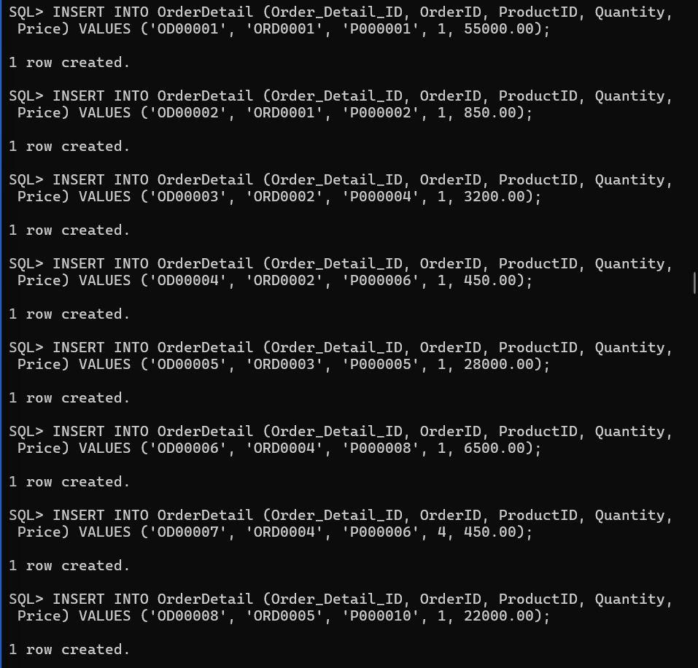
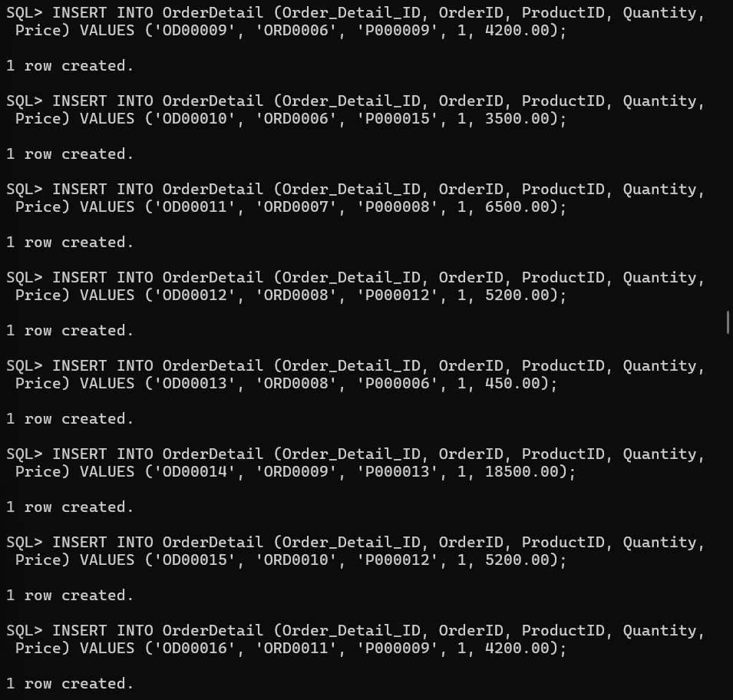
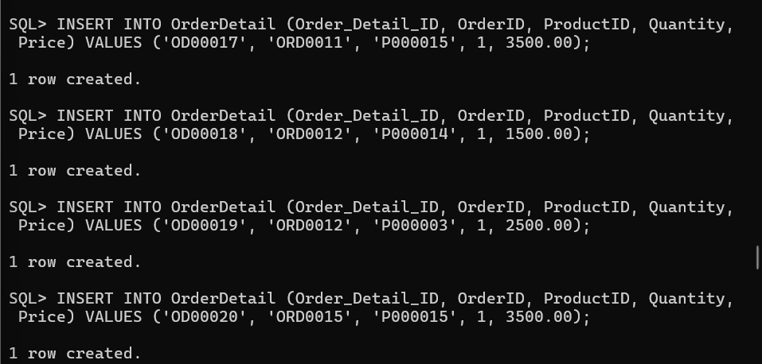
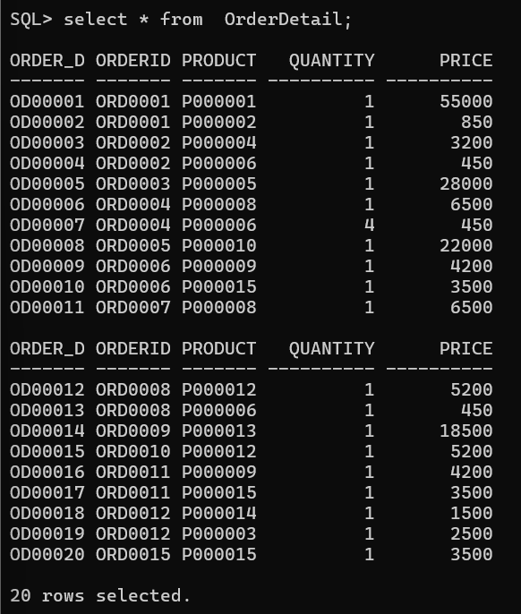

Update Operation
Modify order information.
Examples:
● Change order status from Pending to Delivered.

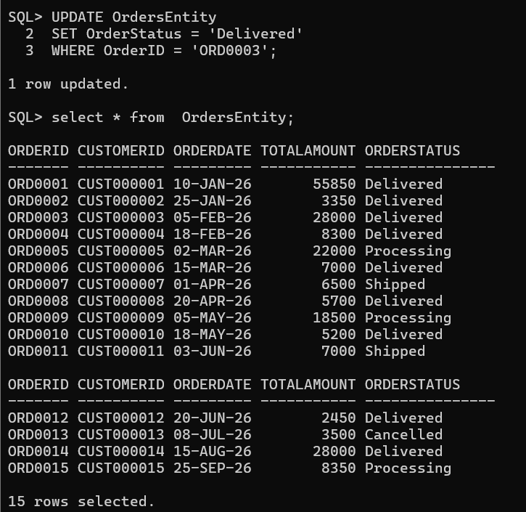
● Update product quantity.
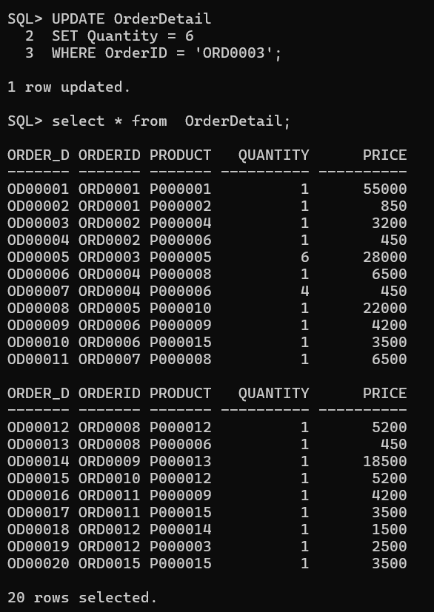
Delete Operation
Remove cancelled orders. Example: "Delete orders cancelled by customers."
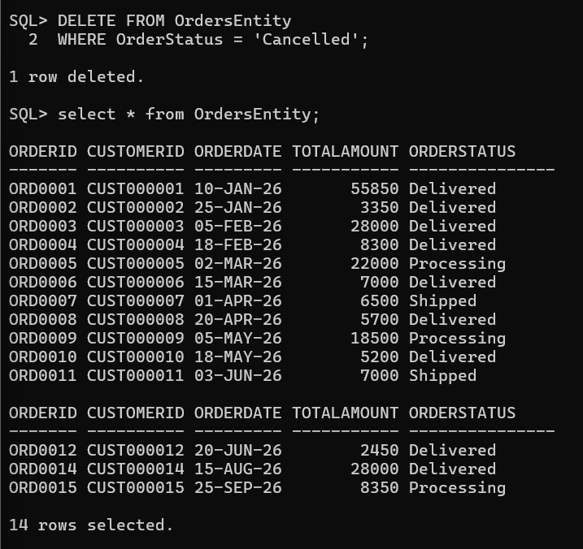
5. Generate Customer Order History Reports
Write SQL queries to generate reports.
Report 1: Customer Order History
Display:
● Customer Name
● Order ID
● Order Date
● Total Amount
● Status
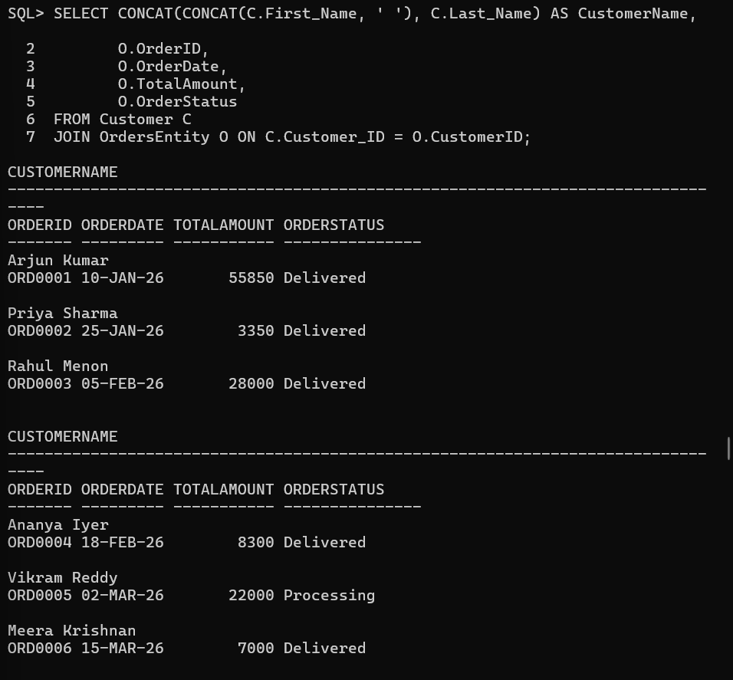
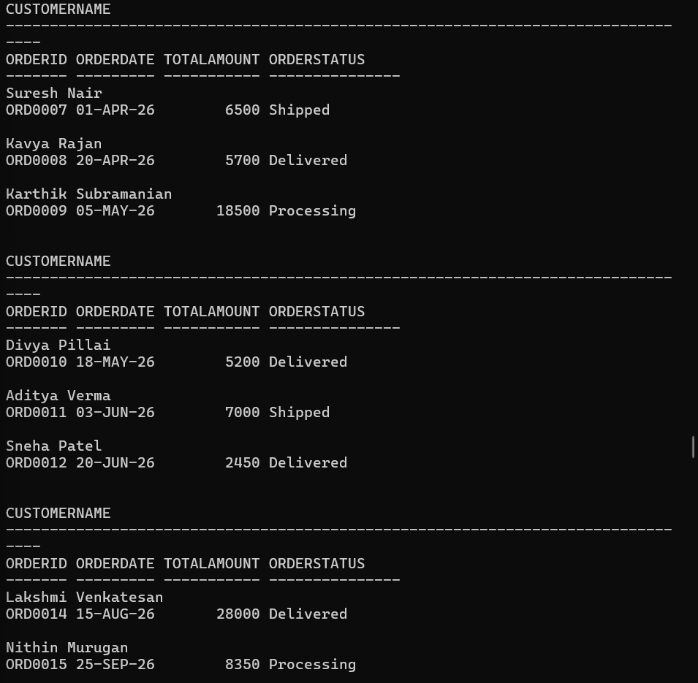
Customer Purchase Analysis
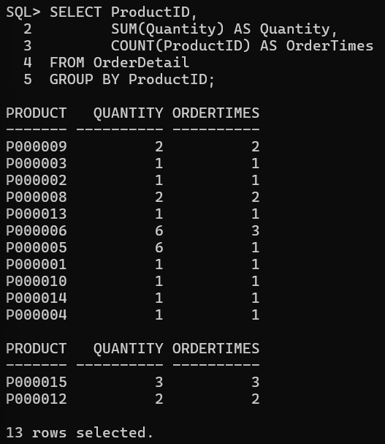
Customer Order Report
